**HTML PROGRAMS**

***Example1***

<!DOCTYPE html>

<html>

    <head>

    </head>

    <body>

        <h2>

            HTML BUTTONS

        </h2>

        <p>

            HTML buttons are defined with the button tag:

        </p>

        <button>

            Click Me

        </button>

    </body>

</html>

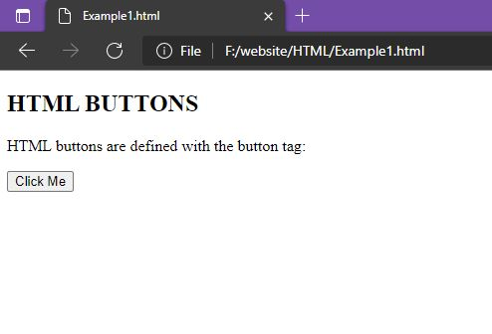

***Example 2***

<html>

    <body>

        <h2>

            HTML IMAGES

        </h2>

        <p>

            HTML images are defined with the img tag

        </p>

        <img src="html.png" height="300" width="600">

    </body>

</html>

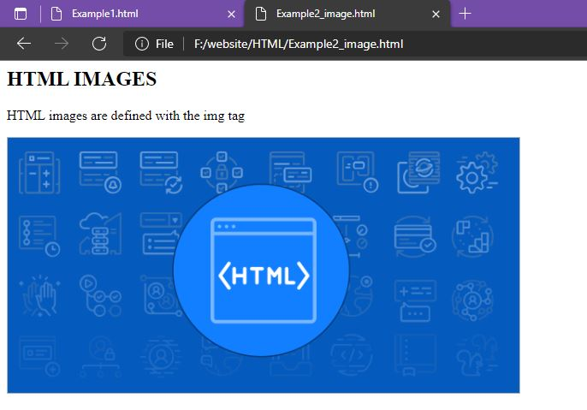

***Example 3***

<html>

    <body>

        <h2>

            AN UNORDERED LIST

        </h2>

        <ul>

            <li>Coffee</li>

            <li>Tea</li>

            <li>Milk</li>

        </ul>

        <h2>

            AN ORDERED LIST

        </h2>

        <ol>

            <li>Coffee</li>

            <li>Tea</li>

            <li>Milk</li>

        </ol>

    </body>

</html>

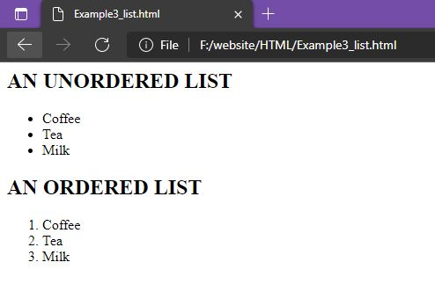

***Example4***

<html>

<body>

<h2>Width and Height Attributes</h2>

<p>The width and height attributes of the img tag, defines the width and height of the image:</p>

<img src="chimchim.jpg" width="500" height="600">

</body>

</html>

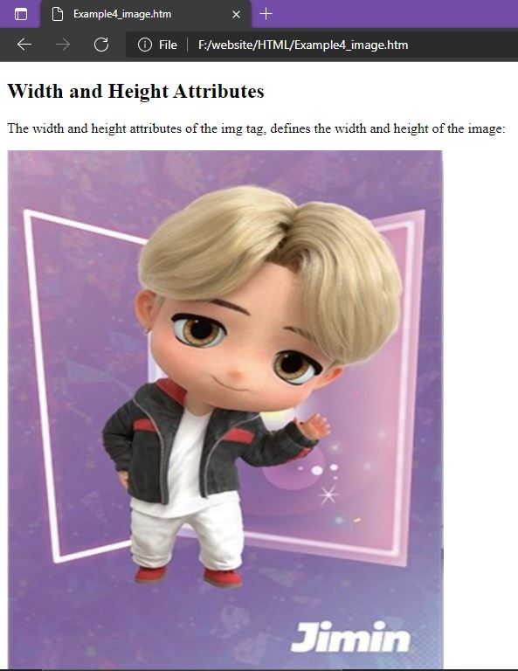

***Example 5***

<html>

    <body>

        <p>

            This is a<br> paragraph with a line break

        </p>

    </body>

</html>

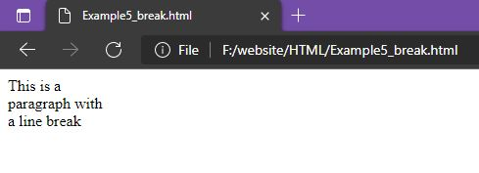

***Example 6***

<html>

    <body>

        <h3 style="color:blueviolet;">Hi My name is Parvathy</h3>

        <p style="color: darkmagenta;">From UST</p>

    </body>

</html>

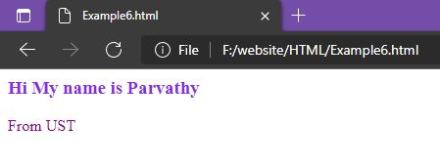

***Example 7***

<html>

    <body>

        <p>My favorite color is <del>Red </del>Purple</p>

    </body>

</html>

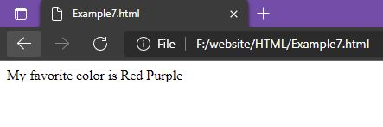

***Example 8***

<html>

    <body>

        <p>My favorite color is <del>Red </del><ins>Purple</ins></p>

    </body>

</html>

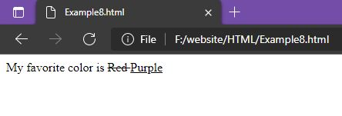

***Example 9***

<html>

    <head>

        <style>

            body {background-color: rgb(220, 153, 233);}

            h1 {color:brown;}

            p{color:darkslateblue}

        </style>

    </head>

    <body>

        <h1>This is heading 1</h1>

        <p>This is paragraph</p>

    </body>

</html>

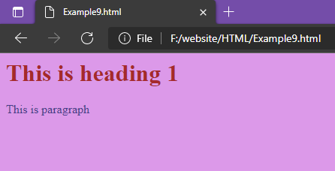

***Example 10***

<html>

    <head>

        <link rel="stylesheet" href="styles.css">

    </head>

    <body>

        <h1> This is h1</h1>

        <p> This is Paragraph</p>

    </body>

</html>

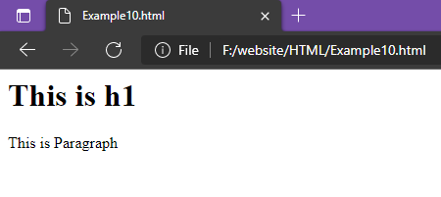

***Example 11***

<html>

    <head>

        <style>

            p{

                border: 2px solid powderblue;

            }

        </style>

    </head>

    <body>

        <h1>This is a heading</h1>

        <p>This is a paragraph.</p>

        <p>This is a paragraph.</p>

        <p>This is a paragraph.</p>

    </body>

</html>

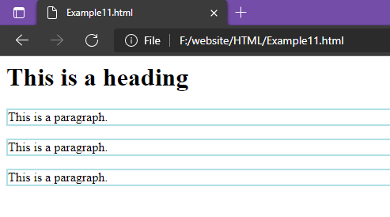

***Example 13***

<html>

    <head>

        <style>

            table, th, td{

                border: 1px solid black;

                border-collapse: collapse;

            }

            th,td{

                padding: 5px;

            }

        </style>

    </head>

    <body>

        <table>

            <tr>

                <td>

                    <p>Paragraph 1</p>

                    <p>Paragraph 2</p>

                </td>

                <td>

                    This cell contains a table

                    <table>

                        <tr>

                            <td>A</td>

                            <td>B</td>

                        </tr>

                        <tr>

                            <td>C</td>

                            <td>C</td>

                        </tr>

                    </table>

                </td>

            </tr>

            <tr>

                <td> this cell contain a list

                    <ul>

                        <li>Apple</li>

                        <li>Orenge</li>

                        <li>Banana</li>

                    </ul>

                </td>

                <td>

                    Hello

                </td>

            </tr>

        </table>

    </body>

</html>

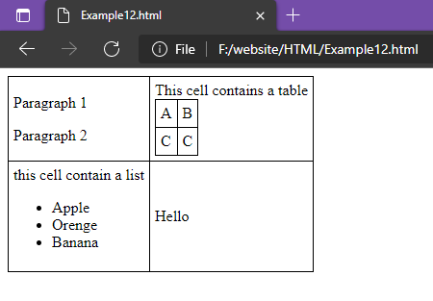

***Example 13***

<html>

    <body>

        <h2>Ordered List with Letters</h2>

        <ol type="A">

            <li>Coffee</li>

            <li>Tea</li>

            <li>Milk</li>

        </ol>

    </body>

</html>

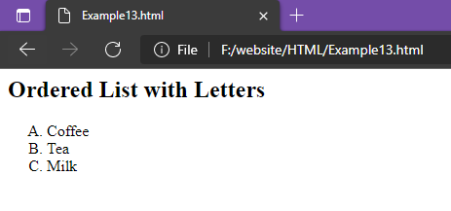

***Example 14***

<html>

    <body>

        <div style="background-color:black;color:white;padding:20px;">

            <h2>London</h2>

            <p>London is the capital city of England. It is the most populous city in the United Kingdom, with a metropolitan area of over 13 million inhabitants.</p>

            <p>Standing on the River Thames, London has been a major settlement for two millennia, its history going back to its founding by the Romans, who named it Londinium.</p>

        </div>

    </body>

</html>

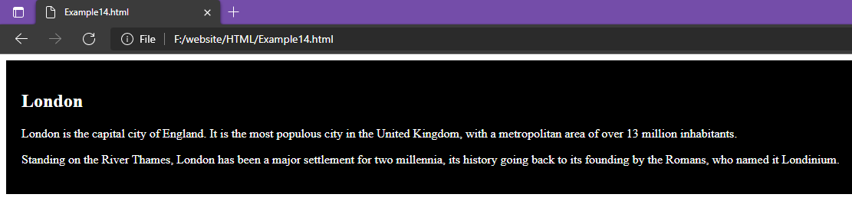

***Example 15***

<html>

    <body>

        <h2> HTML Iframes</h2>

        <p> An iFrame is used to display a webpage within a webpage</p>

        <iframe src="Example14.html"></iframe>

    </body>

</html>

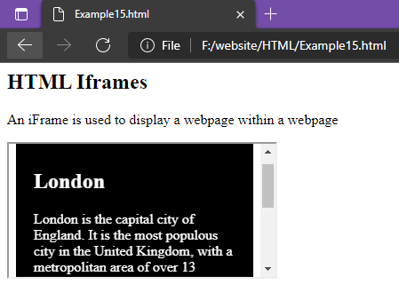

***Example 16***

<html>

    <body>

        <h2>HTML Forms</h2>

        <form action="/action_page.php">

            <label for="fname">First Name: </label><br>

            <input type="text" id="fname" name="fname" value="Parvathy"><br>

            <label for="lname">Last Name: </label><br>

            <input type="text" id="lname" name="lname" value="Madhu"><br><br>

            <input type="Submit" value="Submit">

        </form>

        <p>If you click the "Submit" button, the form-data will be sent to a page called "/action_page.php".</p>

    </body>

</html>

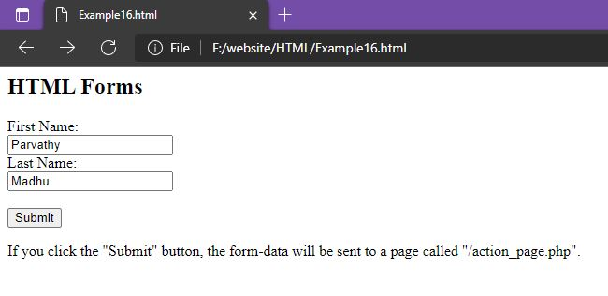

***Example 17***

<html>

    <body>

        <h2>Date Field</h2>

        <p>The <strong>input type="date"</strong> is used for input fields that should contain a date.</p>

        <form action="/action_page.php">

            <label for="birthday">Birthday:</label>

            <input type="date" id="birthday" name="birthday">

            <input type="submit" value="Submit">

        </form>

    </body>

</html>

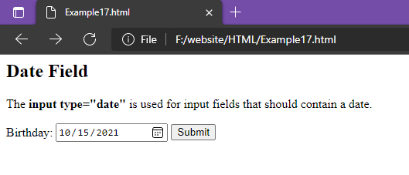

***Example 18***

<html>

    <body>

        <h2>Checkbox</h2>

        <p>The <strong>input type="Checkbox"</strong>defines a checkbox</p>

        <form action="/action_page.php">

            <input type="checkbox" id="vehicle1" name="vehicle1" value="Bike">

            <label for="vehicle1"> I have a Bike </label> <br>

            <input type="checkbox" id="vehicle2" name="vehicle2" value="Car">

            <label for="vehicle2"> I have a Car </label><br>

            <input type="checkbox" id="vehicle3" name="vehicle3" value="Boat">

            <label for="vehicle3"> I have a Boat </label><br>

        </form>

    </body>

</html>

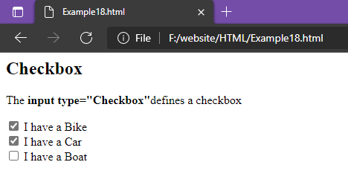

***Example 19***

<html>

    <body>

        <h2> My first webpage</h2>

        <p>My first Paragraph</p>

        <p>Never call document.write after the document has finished loading.

            It will overwrite the whole document.</p>

        <script>

            document.write(5+6);

        </script>

    </body>

</html>

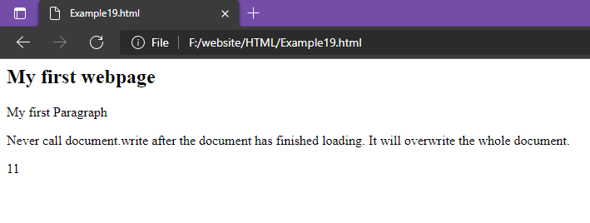

***Example 20***

<html>

    <bod>

        <h2>JavaScript Expressions</h2>

        <p>Expressions compute to values.</p>

        <p id="demo"></p>

        <script>

            document.getElementById("demo").innerHTML=5*10;

        </script>

    </bod>

</html>

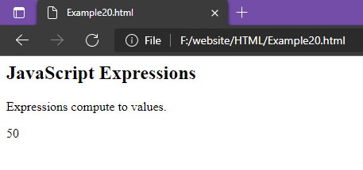

***Example 21***

<html>

    <body>

        <h2>JavaScript Functions</h2>

        <p>This example calls a function which performs a calculation and returns the result:</p>

        <p id="demo"></p>

        <script>

            var x=myFunction(4,3);

            document.getElementById("demo").innerHTML=x;

            function myFunction(a,b){

                return a*b;

            }

        </script>

    </body>

</html>

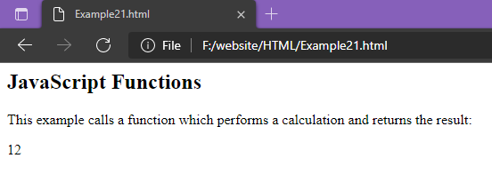

***Example 22***

<html>

    <body>

        <h2>JavaScript String Methods</h2>

        <p>Display the first array element, after a string split:</p>

        <p id="demo"></p>

        <script>

            let text="a,b,c,d,e,f";

            const myArray= text.split(",");

            document.getElementById("demo").innerHTML=myArray[0];

        </script>

    </body>

</html>

